BIO-RATIONAL MANAGEMENT OF FALL ARMYWORM (SPODOPTERA FRUGIPEDA) (LEPIDOPTERA: NOCTUIDAE) IN TANZANIA

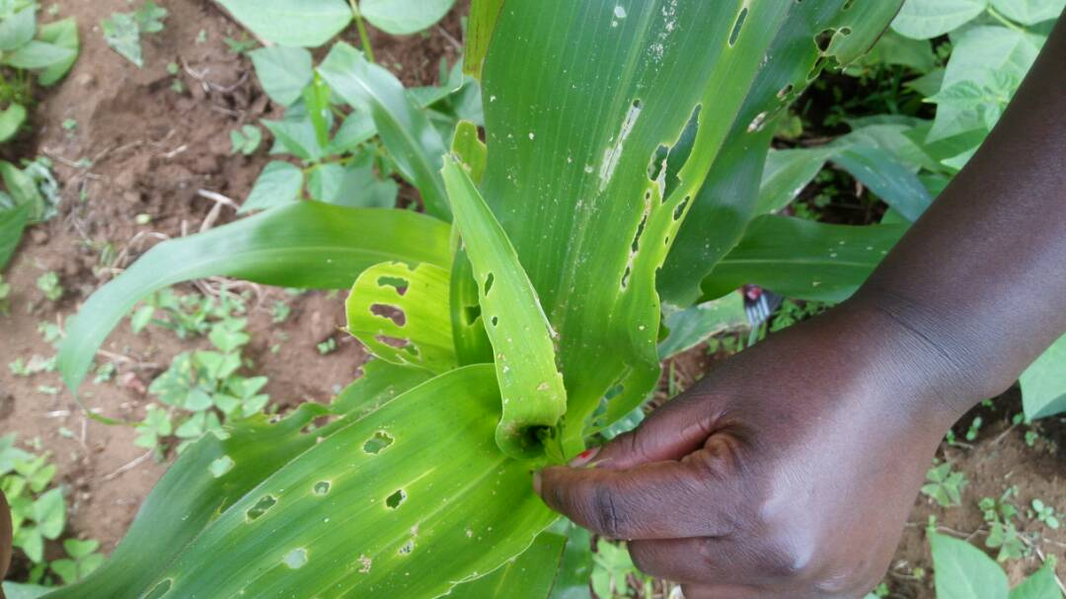
2017
BY
CHIDEGE MANENO (PLANT ENTOMOLOGIST)
TPRI
P.O.Box 3024,
Arusha – Tanzania

ABSTRACT: The experimental trials to determine the efficacy of biorational products (Biotrine: Abamectine 5%, Antario: Bucciluss thuringiensis and abamectin 0.1% and Recharge: Meterihzium anisoplie) against fall armyworm (Lepidoptera: Noctuidae) were conducted between June and September 2017. Using farmer’s fields winter maize (Zea maize) in; Arusha (Mwandet ward) Kilimanjaro (lyamungo ward) and Morogoro (Ifakara) regions of Tanzania. The products were treated at 14 days intervals after the initial appearance of damage symptoms and presence of 1st and 2nd instars larva in maize by spraying Biotrine first at the rate of 1ml per 1litre of water, subsequently, Antario at 1g per 1litre of water and Recharge at 1g per 1litre of water. On the other hand neighbouring farmers were left at liberty to use their common management practices/options. Three separated farms of approximately a hectare for each region were selected to constitute an experimental unit, After three months the treated farms were assessed by dividing each hectare into five small plots, twenty plants were examined for each plot to obtain one hundred plants assessed in each hectare, percent (%) damaged plants against undamaged ones were determined, likewise, for untreated farms in neighbouring farms. The results showed that, mean percent damaged plants was less than 5%, achieving a 95% FAW control for biorational products treated farms whereby, for farmers practiced farms showed more than 25% damaged plants. This indicates the potency of the technology against fall armyworm in Tanzania.

Key words: Spodoptera frugperda, biotrine, Antario, Recharge, Tanzania, invasive

- INTRODUCTION AND BACKGROUND INFORMATION
Fall armyworm (Spodoptera frugiperda) belongs to the order Lepidoptera; noctuidae family, is an alien, invasive moth insect pest native to tropical and subtropical regions of the Americas. it was detected in 2016 in African countries; Nigeria, Sao Tomé, Benin and Togo (IITA, 2016; IPPC, 2016). It has also been confirmed in Ghana (CABI, 2017), Zimbabwe (FAO, 2017), Swaziland (IPPC, 2017), Kenya (Republic of Kenya Ministry of Agriculture, Livestock and Fisheries, 2017), Zambia (IPPC, 2017d) and Congo Democratic Republic (IPAPEL-FAO, 2017), and there are preliminary reports of the pest in Malawi, Mozambique (IPPC, 2017), Namibia and South Africa (BBC, 2017).
1.1 Impacts of fall armyworm and the need for African interventions
Invasion of a species into an area where it has never been before has both ecological and economic consequences [4]. Ecologically, invasion perturbs the natural ecosystem by co-existing with or competing against native organisms as well as associated pesticides impacts on beneficial organisms [4]. Economically, the expected crop losses caused by a particular pest and inappropriate use of insecticides against the pest can double the cost of crop production and thereby reduce profit. All these impacts are detrimental to country’s sustainable food security and biodiversity conservation programs [10] [16] and [1].
Fall armyworm is an invasive, a strong flier and a migratory pest, It disperses long distances annually during the summer months [20].They feed on grassy plants, in particular economically important crops such as maize, millet, sorghum, rice, wheat, and sugarcane. Other crops of major agricultural importance attacked by this pest includes; cowpea, peanut, potato, soybean, and cotton [12] [5] [2] [19]. In Brazil, the third largest maize producer in the world, S. frugiperda is considered the most important pest on this crop causing a damage estimated at more than US$400 million annually. Caterpillars of S. frugiperda seem to be much more damaging to maize than most other African Spodoptera species [14]. Its damage results from leaf-eating and healthy plants usually recover quite quickly, but a large pest population can cause defoliation and resulting yield losses; the larvae then migrate to adjacent areas in true armyworm fashion.
In Nicaragua, van Huis (1981) found a 33% increase in maize yield when plants were protected with insecticide. Infestations during the mid- to late-whorl stage of maize development caused yield losses of 15-73% when 55-100% of the plants were infested with S. frugiperda (Hruska and Gould, 1997). Caterpillars of S. frugiperda appear to be much more damaging to maize in West and Central Africa than most other African Spodoptera species (IITA, 2016 and Goergen et al,. 2016).
Due to the complex nature of Fall armyworm infestation, high spreading performance, high reproductive capacity and wide host range, it is most likely that the pest will soon be able to colonize most African countries and pose great impact to countries food security and livelihood. Preliminary identification results shows that, some parts of Tanzania has been invaded by the pest and farmers used several insecticides to cab the pest unsuccessful. It is crucial to take appropriate control measures including screening of sustainable control measures against the moth for the country. This is therefore the essence of this study in particular.

- OBJECTIVE
To determine the effectiveness of bio rational products (Biotrine:Abamectine 5%, Antario Bucciluss thuringiensis and abamectin 0.1%: and Recharge: Meterihzium anisoplie) in Tanzania.

MATERIALS AND METHODS

3.1 Study sites
The experimental trials were conducted in Tanzania at Mwandet ward of Arusha, Lyamungo ward of Kilimanjaro and Ifakara ward of Morogoro regions from June and September 2017 winter maize.

3.2 The experimental design, layout and treatment combination
The trials involved farmer’s fields chosen during the initial diagnostic survey as the investigator guided by ward extension officers. This involved field inspection and identification of plant damages (plate 1) and presence of insect pest larva (plate 2), three farms of approximately a hectare were sprayed with bio rational products and three hectares were left to farmers commonly management practices/options for each location.
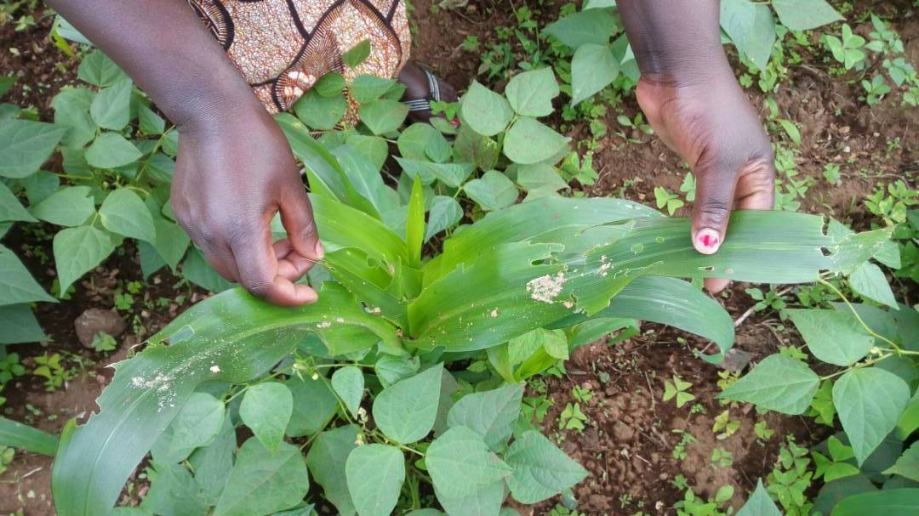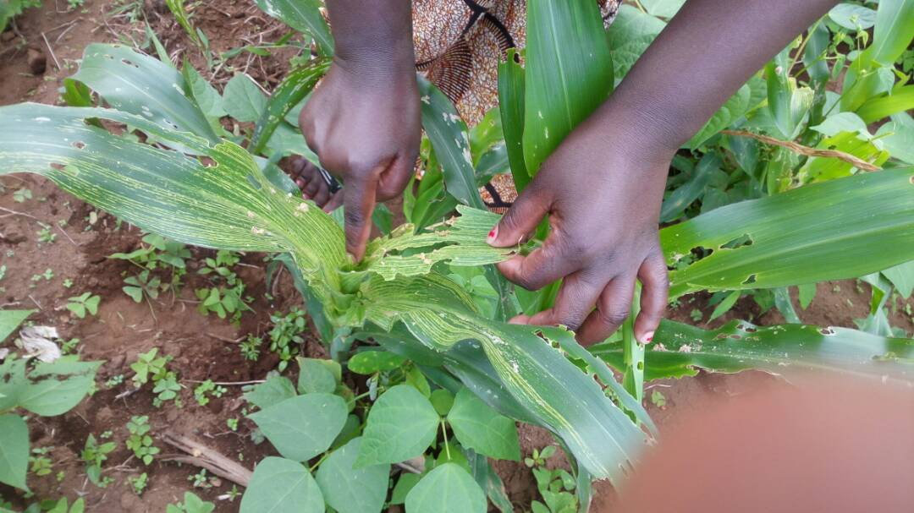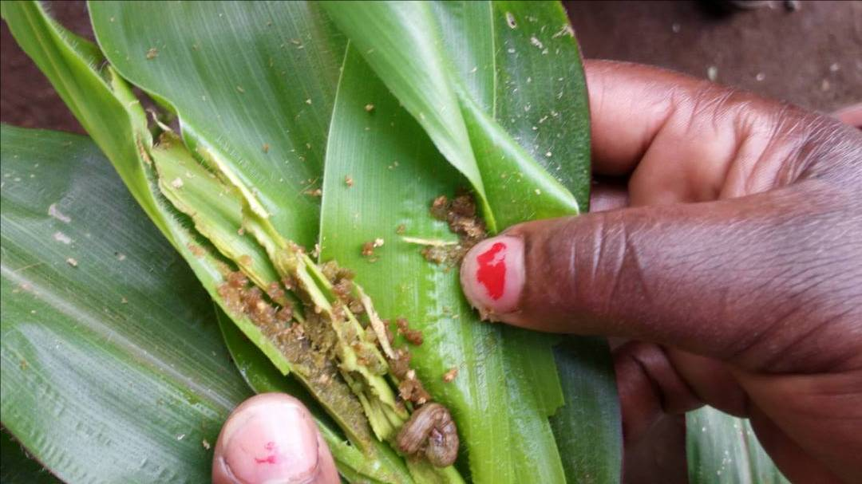
Plate 1: Maize damaged plants by FAW during initial surveys for identification of the pest
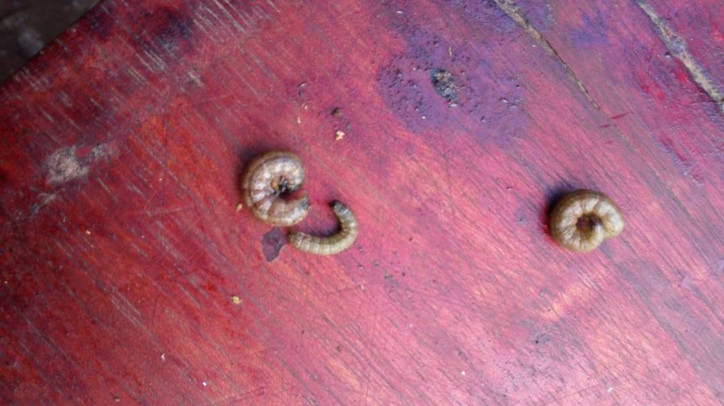
Plate 2: different FAW larva instars obtained during initial surveys.

3.3 Data Collection and Analysis
Data on plant damages were collected by counting the number of plants with shot holes, windowed or completely damaged plants against the undamaged ones. Each field was divided into five small plots and twenty plants were examined for damage symptoms to obtain 100 plants and the results were expressed in percentage (%). Data were analysed using MS-excel soft ware to obtain means differences and presented in graphs according.
- RESULTS AND DISCUSSION
The results obtained indicated that, Fall armyworm infested plants in the farmers practices (FP)-treated in Kilimanjaro trials ranged from 20 to 30% damage while in that of biorational (BR), that is ; Biotrine (Abamectin 5%), Antario (Bacillus thuringiensis kurstaki and abamectin 0.1%) and recharge (Metarhizium anisopliae)-treated farms were below 5% damage (figure 1).
It was also noted in Morogoro trials that, the farmers practices (FP)-treated trials ranged from 15 to 20% damage while in that of Biorational (BR) treated farms were between 1 to 5% plant damage (figure 2).
On the same venture, It was evident also in Arusha trials that, the farmers practices (FP)-treated trials ranged from 25 to 30% damage but the Biorational (BR) treated farms had between 1 to 5% plant damage (figure 3).
The results from all the locations indicate that, biorational products offers significance FAW management when treated appropriate and timely.
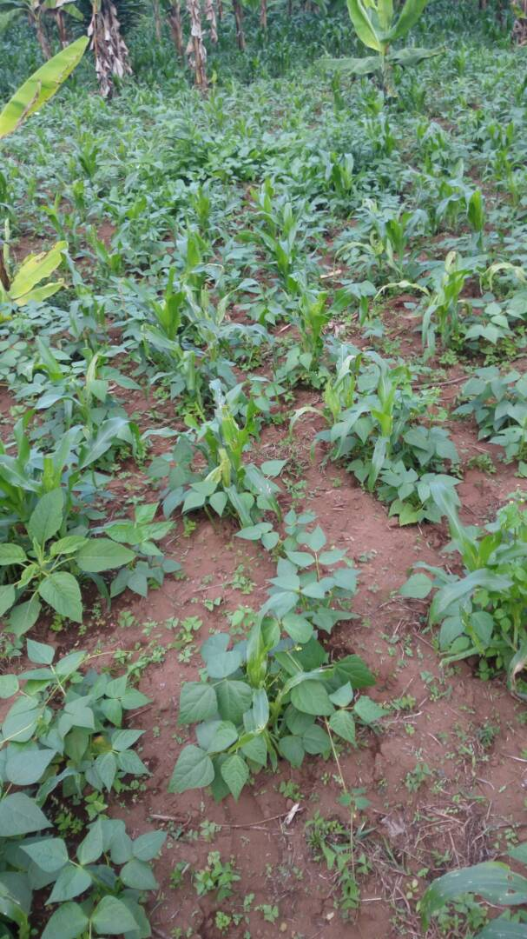
Plate 3: Farmers practice maize field with FAW damage in Kilimanjaro

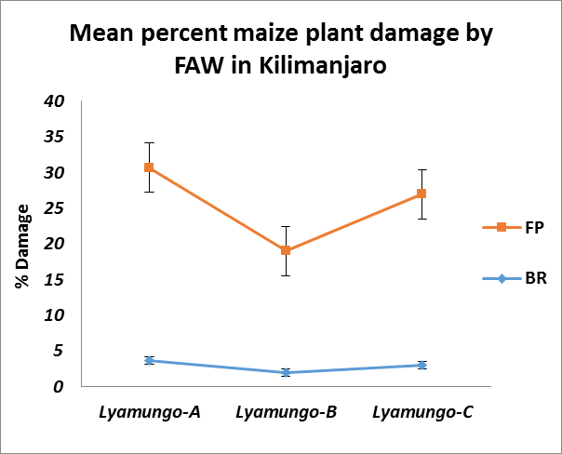
Figure 1: Mean percent maize plant damage by FAW in Kilimanjaro under farmers practice (FP) and biorational products (BR) management.

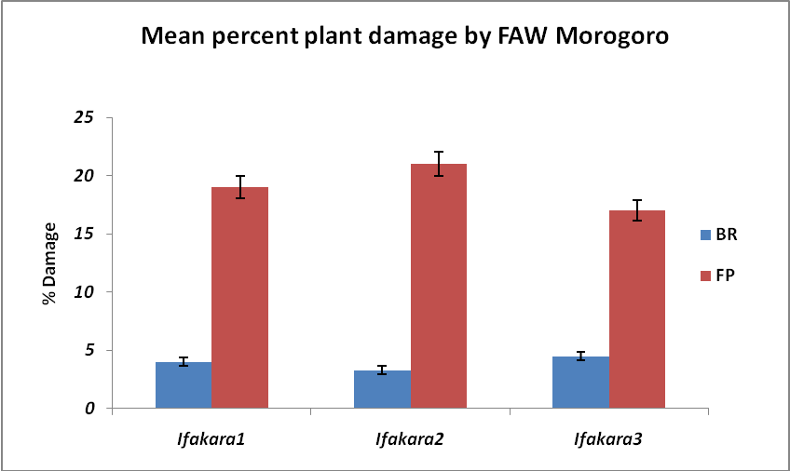
Figure 2: Mean percent maize plant damage by FAW in Morogoro under farmers practice (FP) and biorational products (BR) management.

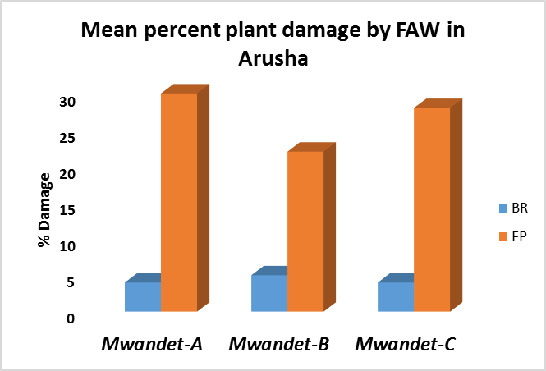
Figure 3: Mean percent maize plant damage by FAW in Arusha under farmers practice (FP) and biorational products (BR) management.

CONCLUSION AND RECOMMENDATION
In conclusion, it was quite clear for this study that, in all locations results revealed the potency of the technology; Biotrine (Abamectin 5%), Antario (Bacillus thuringiensis kurstaki and abamectin 0.1%) and recharge (Metarhizium anisopliae) against fall armyworm (Spodoptera frugiperda). This scientific outcome therefore recommends the use of the technology but emphasis on timely and appropriate spraying techniques, proper inspection, scouting and field identification of early larva instars and plant damage symptoms are put forward for sustainable management of the pest in Tanzania.

- ACKNOWLEDGEMENT
We are grateful to TPRI Administration for logistical support, Mr. Sanale of Mwandet-Arusha, Mr Ngeje of Ifakala- Morogogo and Mr. Olomi of Lyamungo-Machame, Kilimanjaro for allowing us their farms for this study. We are especially indebted to Russell IPM for financing the study.

7.0 References:
- Bellard, C. and Jeschke, J. M. (2016). A spatial mismatch between invader impacts and research publications. Conserv. Biol. 30, 230–232
- Bernal, J. S., J. E. Melancon, and K. Zhu-Salzman. 2015. Clear advantages for fall armyworm larvae from feeding on maize relative to its ancestor Balsas teosinte may not reflected in their mother’s host choice. Entomol. Exp. Appl. 155: 206–217
- Chidege M, Shakil Al-zaidi, Nayem Hassan, Abisgold Julie, Elialilia Kaaya and Sheila Mrogoro (2016), First record of tomato leaf miner Tuta absoluta (Meyrick) (Lepidoptera: Gelechiidae) in Tanzania, Agriculture & Food Security (2016) 5:17, DOI 10.1186/s40066-016-0066-4
- De Lange, E. S., D. Balmer, B. Mauch-Mani, and T.C.J. Turlings. 2014. Insect and pathogen attack and resistance in maize and its wild ancestors, the teosintes. New Phytologist 204: 329–341.
- Goergen G, Kumar PL, Sankung SB, Togola A, Tamò M (2016) First Report of Outbreaks of the Fall Armyworm Spodoptera frugiperda (J E Smith) (Lepidoptera, Noctuidae), a New Alien Invasive Pest in West and Central Africa. PLoS ONE 11(10): e0165632. doi:10.1371
- IITA (2016), First report of outbreaks of the “Fall Armyworm” on the African continent bulletin no. 2330. http://bulletin.iita.org/index.php/2016/06/18/first-report-of-outbreaks-of-the-fall-armyworm-on-the-african-continent/ Accessed on 17/12/2016.
- International Association for Plant Protection Science (2016), first report of outbreaks of the ‘fall armyworm’ on the African continent, News letter number X. https://www.plantprotection.org/Portals/0/documents/Newsletters/2016/IAPPS2016-10.pdf Accessed on 17/12/2016.
- Kenis, M. Marie-Anne Auger-Rozenberg, Alain Roques, Laura Timms, Christelle Pee, Matthew J. W. Cock,Josef Settele, Sylvie Augustin, Carlos Lopez-Vaamonde (2009) Ecological effects of invasive alien insects. Biol. Invasions 11, 21–45.
- Muru´a, M. G., M. T. Vera, S. Abraham, M. L. Ju arez, S. Prieto, G. P. Head, and E.Willinki. 2008. Fitness and mating compatibility of Spodoptera frugiperda (Lepidoptera: Noctuidae) populations from different host plant species and regions in Argentina. Ann. Entomol. Soc. Am. 101: 639–64 9.
- NAGOSHI, R. N., AND R. L. MEAGHER (2008) Review Of Fall Armyworm (Lepidoptera: Noctuidae) genetic complexity and migration, Florida Entomologist 91(4) 546- 554.
- NAGOSHI, R. N., AND R. L. MEAGHER. 2004. Seasonal distribution of fall armyworm (Lepidoptera: Noctuidae) host strains in agricultural and turf grass habitats. Environ. Entomol. 33: 881-889.
- Nagoshi, R. N., P. Silvie, R. L. Meagher, Jr., J. Lopez, AND V. Machado. 2007. Identification and comparison of fall armyworm (Lepidoptera: Noctuidae) host strains in Brazil, Texas, and Florida. Ann. Entomol. Soc. America 100: 394-402.
- Paini, D. R Sheppard AW, Cook DC, De Barro PJ, Worner SP, Thomas MB. Global threat to agriculture from invasive species. Proc. Natl Acad. Sci. USA 113, 7575–7579 (2016).
- Wolf,W.W.,J.K.Westbrook, J.Raulston, S.D.Pair, and S.E Hobbs. 1990. Recent air borne radar observations of migrant pests in the United States. Philos.Trans.R.Soc.Lond.Ser. B328:619–630.

