Stand Out From the Crowd with Fast and Easy Check Customization
Step by step guide on how to add logo to bank check.
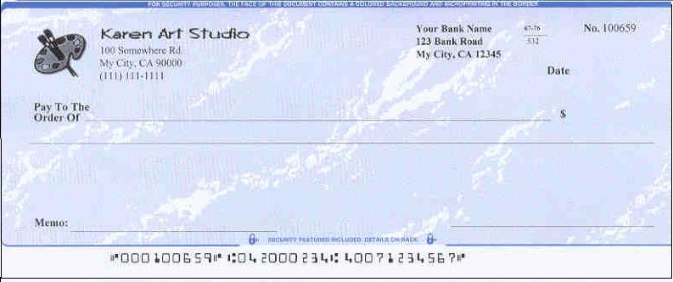
You will never know who will handle your checks. The customized bank checks are also a great way to differentiate your company and get your brand out in the marketplace. We expect ezCheckPrinting check printing software can give users more controls on check design and printing. So you can customize your bank checks easily.
A company logo on the bank checks is an efficient way to catch more eyeballs. Followings are the four easy steps to design and print the bank check with a logo.

Step 1: Install ezCheckPrinting
If you have not installed ezCheckPrinting, you can download it from
http://www.halfpricesoft.com/check_printing_software_download.asp
Just follow the instructions on the download page to finish the installation. This software is compatible with the latest Windows 7 system (32-bit or 64-bit).

Step 2: Setup your bank account and add the logo image.
Click the top menu "Settings->check setup" to open the check setup page. Set up your check information and add your company logo file there.
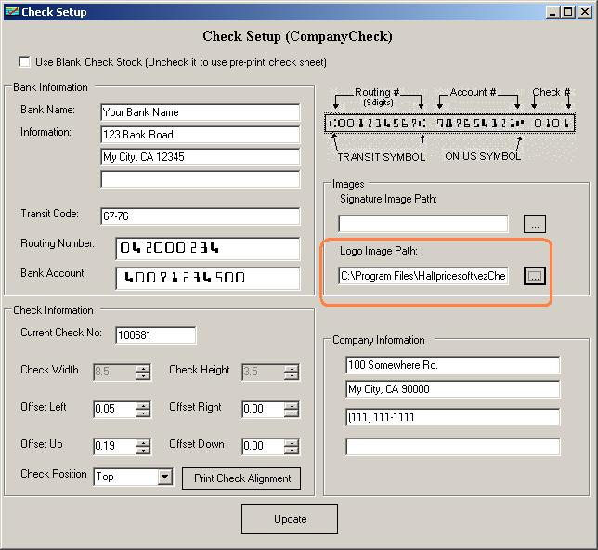

Step 3: Customize the check layout
(This feature is just available with the full version.)
Click the top menu "Settings->Check layout" to open the check layout page. You can customize the layout of your check by changing the font size, logo position, logo size or add a new label.
To customize the logo, you need to select the logo from the item picker first. Then you can resize it or drag/drop the logo to a new position. If you are satisfied with the effect, you can save your change.
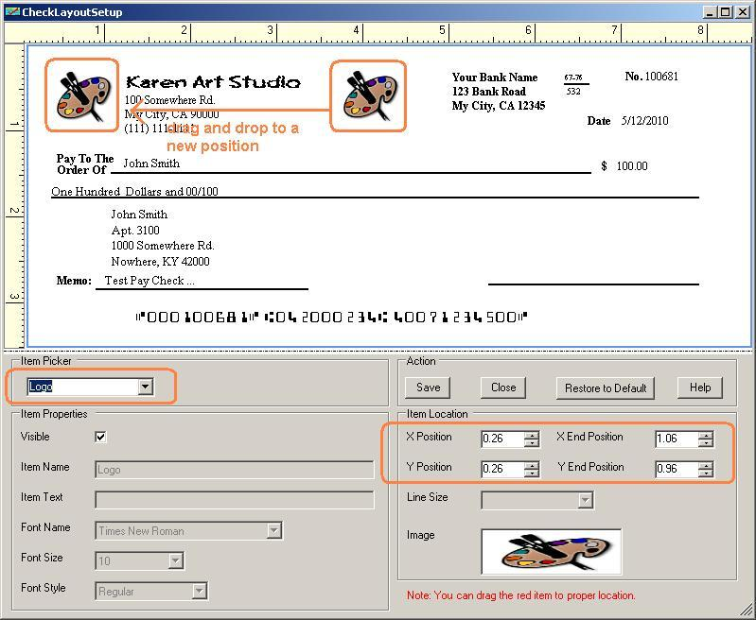

Step 4: Add a new check and print it.
Go back to the main page. Click the New button to add a check. Select this check from the check list and click the Print button to print your check.
Please feel free to download and try ezCheckPrinting Software. No registration needed and no obligation.
You can even get this software and the compatible blank check paper for FREE if you check out through TrialPay.
http://www.halfpricesoft.com/business-free-special-offer.asp
 

