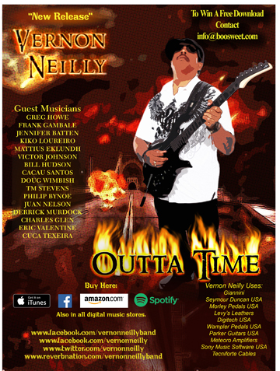
BOOSWEET RECORDS
VERNON NEILLY
OUTTA TIME

- Fire Single Edit feat. Greg Howe, Vernon Neilly (guitar solos) Vernon Neilly (vocals) TM Stevens (bass)
- They Don’t Care feat. Doug Wimbish (bass) and Khalif (vocals) Vernon Neilly, Bill Hudson (guitar solos)
- Outta Time feat. Mattias IA Eklundh (guitar solo) Khalif (vocals) TM Stevens (bass) Eric Valentine (drums)
- Git Yo Lyfe Rite feat. Vernon Neilly, Vic Johnson (guitar solos) Vernon Neilly (vocals) TM Stevens (bass) Eric Valentine (drums)
- So Far Away feat. Vernon Neilly (guitar solos & vocals) Charles Glen (bass) Steve Ferrone (drums)
- Nassau Nights feat. Vernon Neilly, Frank Gambale, Cacau Santos (guitar solos) Derrick Murdock (bass) Cuca Texeira (drums)
- Meta Funk Trip feat Vernon Neilly, Kiko Loureiro, Jennifer Batten (guitar solos) Philip Bynoe, Juan Nelson (bass) Cuca Texeira (drums)
- Fire feat. Greg Howe, Vernon Neilly (guitar solos) Vernon Neilly (vocals) TM Stevens (bass)

File Under: Alt Rock, Modern Rock, Pop Rock, Funk Rock, Blues Rock, Classis Rock, Jazz Rock

Retail Promo: Strong retail push to brick and mortar and digital retailers. In store service, visits, promo and merchandise give away. Contest incentives in major markets. Strong video in store push through buy in programs.

Radio Promo: Major push to all genre related radio stations terrestrial, satellite, and internet. Sponsoring of contests, giveaways, ID promos, and interviews to create incentive for maximum exposure support.

Street Promo: Various teams will target their respective cities connecting with Dj’s, Mix Shows, Lifestyle hotspots, handling distribution of promotional materials.

Publicity: Targeted press will be handled by label and hired publicist to solicit features, interviews, and music reviews.

Consumer and Trade Advertising: Target Key publications and newspapers specific to the genre of project such as Guitar Player, Guitar World, Premier Guitar, Total Guitar, as well as their online websites.

Vernon Neillly is no stranger to talent laden musical
projects, and this CD “Outta Time” is no different.
Vernon brings together super virtuoso and legendary
guitar and bass players, Greg Howe, Frank Gambale,
Jennifer Batten, Kiko Loureiro, Mattias IA Eklundh,
Victor Johnson, Doug Wimbish, TM Stevens,
Juan Nelson and others to help him to express his
musical point of view. Although “Outta Time” boasts
supreme musical fire power, it is far more than an
exposition of world class musical abilities. The CD
has a definite message for our times by means of songs
like “They Don’t Care”, “Outta Time”, and the funky
“Git Yo Lyfe Rite”. Strong melodies and hooks will
have the listener singing along. Vernon was heavily
influenced by Jimi Hendrix as a youth, and pays tribute
to the Guitar Hero with is version of “Fire” rearranged and
produced by Vernon and Greg Howe. Vernon and this
all-star cast of virtuosos Greg Howe (Michael Jackson,
Justin Timberlake, Rhianna), Frank Gambale (Chic Corea,
Return To Forever), Jennifer Batten (Michael Jackson, Jeff
Beck), Kiko Loureiro (Angra, Megadeth), Mattias IA Eklundh
(Freak Kitchen), Victor Johnson (Busboys, Total Eclipse, Sammy
Hagar), Doug Wimbish (Living Colour, Jeff Beck, Tarja),
TM Stevens (Steve Vai), Juan Nelson (Ben Harper) and the other
highly skilled musicians bring the heat on “Outta Time”.

All songs written by Vernon Neilly published by VNeilly I Songs BMI

Fire written by Jimi Hendrix published by Experience Hendrix LLC
Universal Music Publishing

