FOR IMMEDIATE RELEASE
Contact: Philip Moser
260-336-8261
pjmsltns@frontier.com

Free and Fearless
By Philip Moser

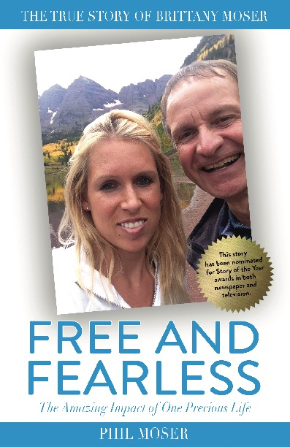
Once every generation comes a story so powerful and personal that it will change the way you look at life. This is the story of Brittany Moser, a spirited talented woman that lived life to the fullest by enriching everyone she encountered. After becoming a flight attendant, she is grounded by a rare and incurable disease. She decides to go on an adventure of a lifetime and asks her best friend, her father Philip, to go with her.
This is the story at that runs through the pages of Philip Moser’s new book, Free and Fearless [June 1, 2019]. Award-nominated, this story is a very personal account of this amazing adventure that will take you to new and exotic places and leave you wanting more.
Moser shares, “I hope the reader of this book laughs, cries, and is inspired. But mostly I hope to take the reader on an adventure of a lifetime that will put one’s everyday problems in their proper perspective. I want to inspire others the same way that I have been inspired.”
In Free and Fearless, Moser details the high and low points of Brittany’s life and how her rare illnesses came to be, the bond the two of them shared that has inspired him to expand his horizons, and the lessons he learned from her to make the most out of life.
After contracting two rare and unexpected diseases, Brittany’s health quickly diminished before she abruptly passed away, leaving the Moser family, not once but twice, in a state of shock and tragedy. “This is a story about the life of Brittany, our spirited, happy-go-lucky child who enjoyed every moment and who has helped me to live my life to its fullest,” Moser shares. “She taught me how to laugh, to love, and to live in a way I never dreamed possible. This book is not about the grief of losing a child, but about making the most out of what we are given and living our lives positively and not out of fear.”
A deeply personal and honest account of the ups and downs of life before, during, and after his daughter’s life-threatening condition, Moser’s Free and Fearless shares the story of Brittany Moser through her father’s eyes. With a pure honesty only one who has experienced such deep loss can share, he uncovers the truths about his own life, the world around him, and the lives of all of the people Brittany has touched. Free and Fearless reminds us to take nothing for granted, and to make the most of every moment, interaction, and relationship that enriches out lives and makes us who we are.
Free and Fearless is the passion project of Philip Moser and just part of his personal movement to make Brittany’s passing meaningful. Moser, the son of a farmer, has pushed himself out of his comfort zone to make Brittany’s story come alive on the page, and to share his family’s narrative with the world.
“The inspiration I received for 32 years far outweighs the fact that Brittany was cut short in life,” continues Moser.
Heartfelt and heart-wrenching, Free and Fearless is an illuminating narrative of courage and strength. Moser is available for interviews, Q&A’s and byline articles around the launch of Free and Fearless to discuss/write on topics including but not limited to:
- How we affect the people around us, both in this life and after we’ve passed
- Keeping an open mind and a positive attitude in order to do things we never thought possible
- Moving away from or overcome what makes us comfortable
- How not to be controlled by fear, especially fear of the inevitable
- Embracing unexpected change and life’s fastest curveballs as a natural part of life

PHILIP MOSER is a resident of Hamilton, Indiana, was born on a family farm, and has worked in the grocery business his entire life. He has worked his way up in the industry and now specializes in category management. Moser married Marilyn Wells in 1978 and raised two incredible daughters, Camille and Brittany.
For more information, please visit www.freeandfearlessbook.com.
Free and Fearless was released nationwide June 1, 2019 and can be ordered on Amazon.

REVIEW COPIES AVAILABLE UPON REQUEST

###

